How to print Monster project with comments, from Google Docs.
First, on the Google Doc, use the File menu to select Download As and then Web Page.
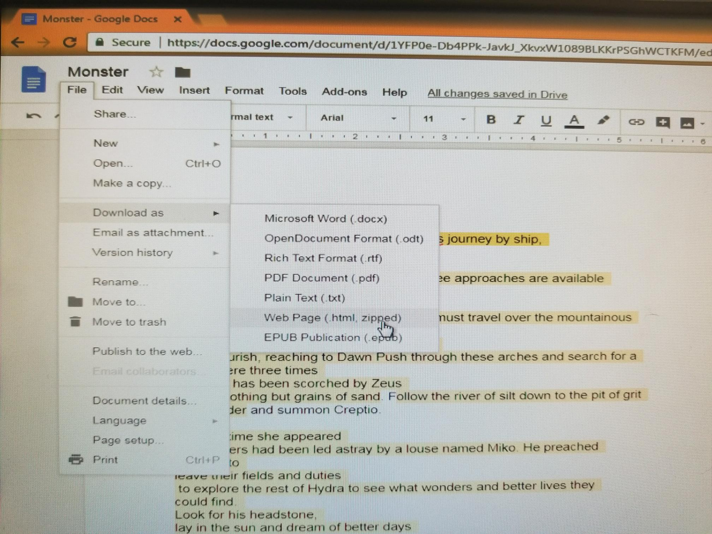
An HTML file will be downloaded to your computer Open that HTML file in a web browser
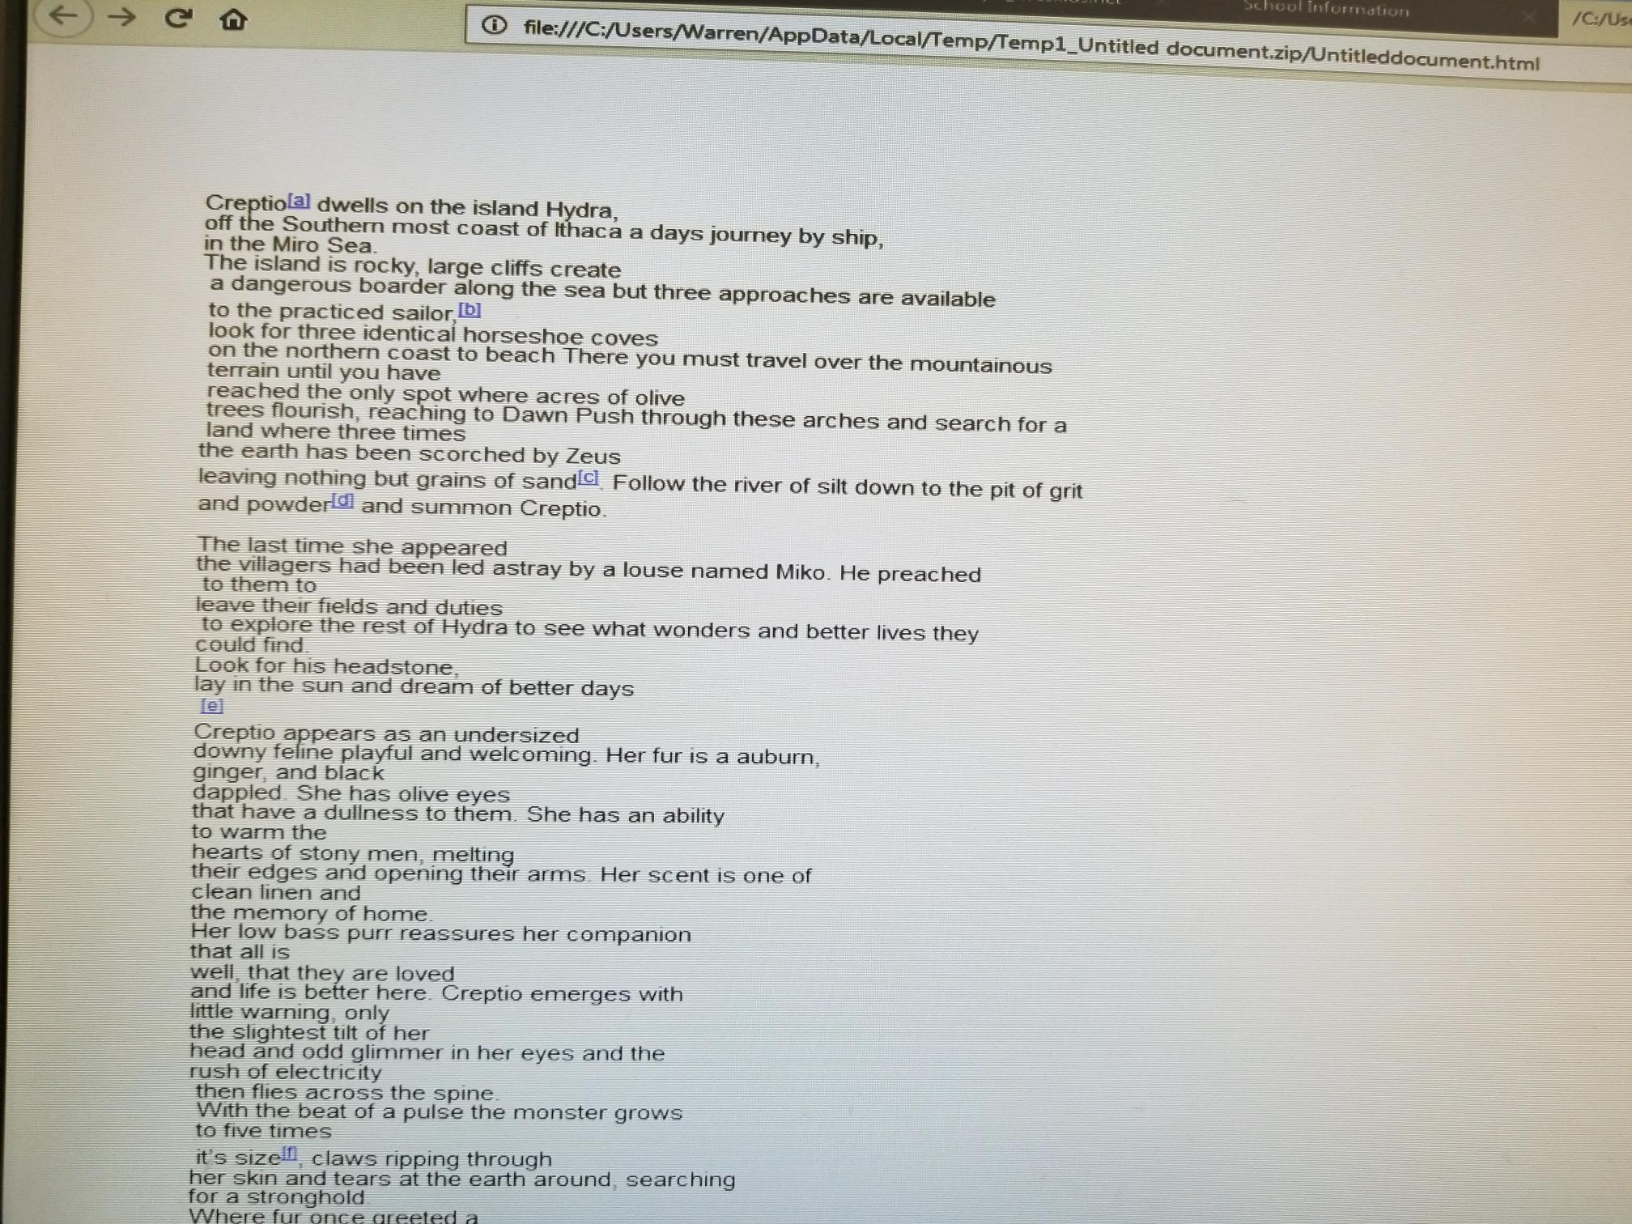
you will see the text of the Google Document with footnotes for each of the comments
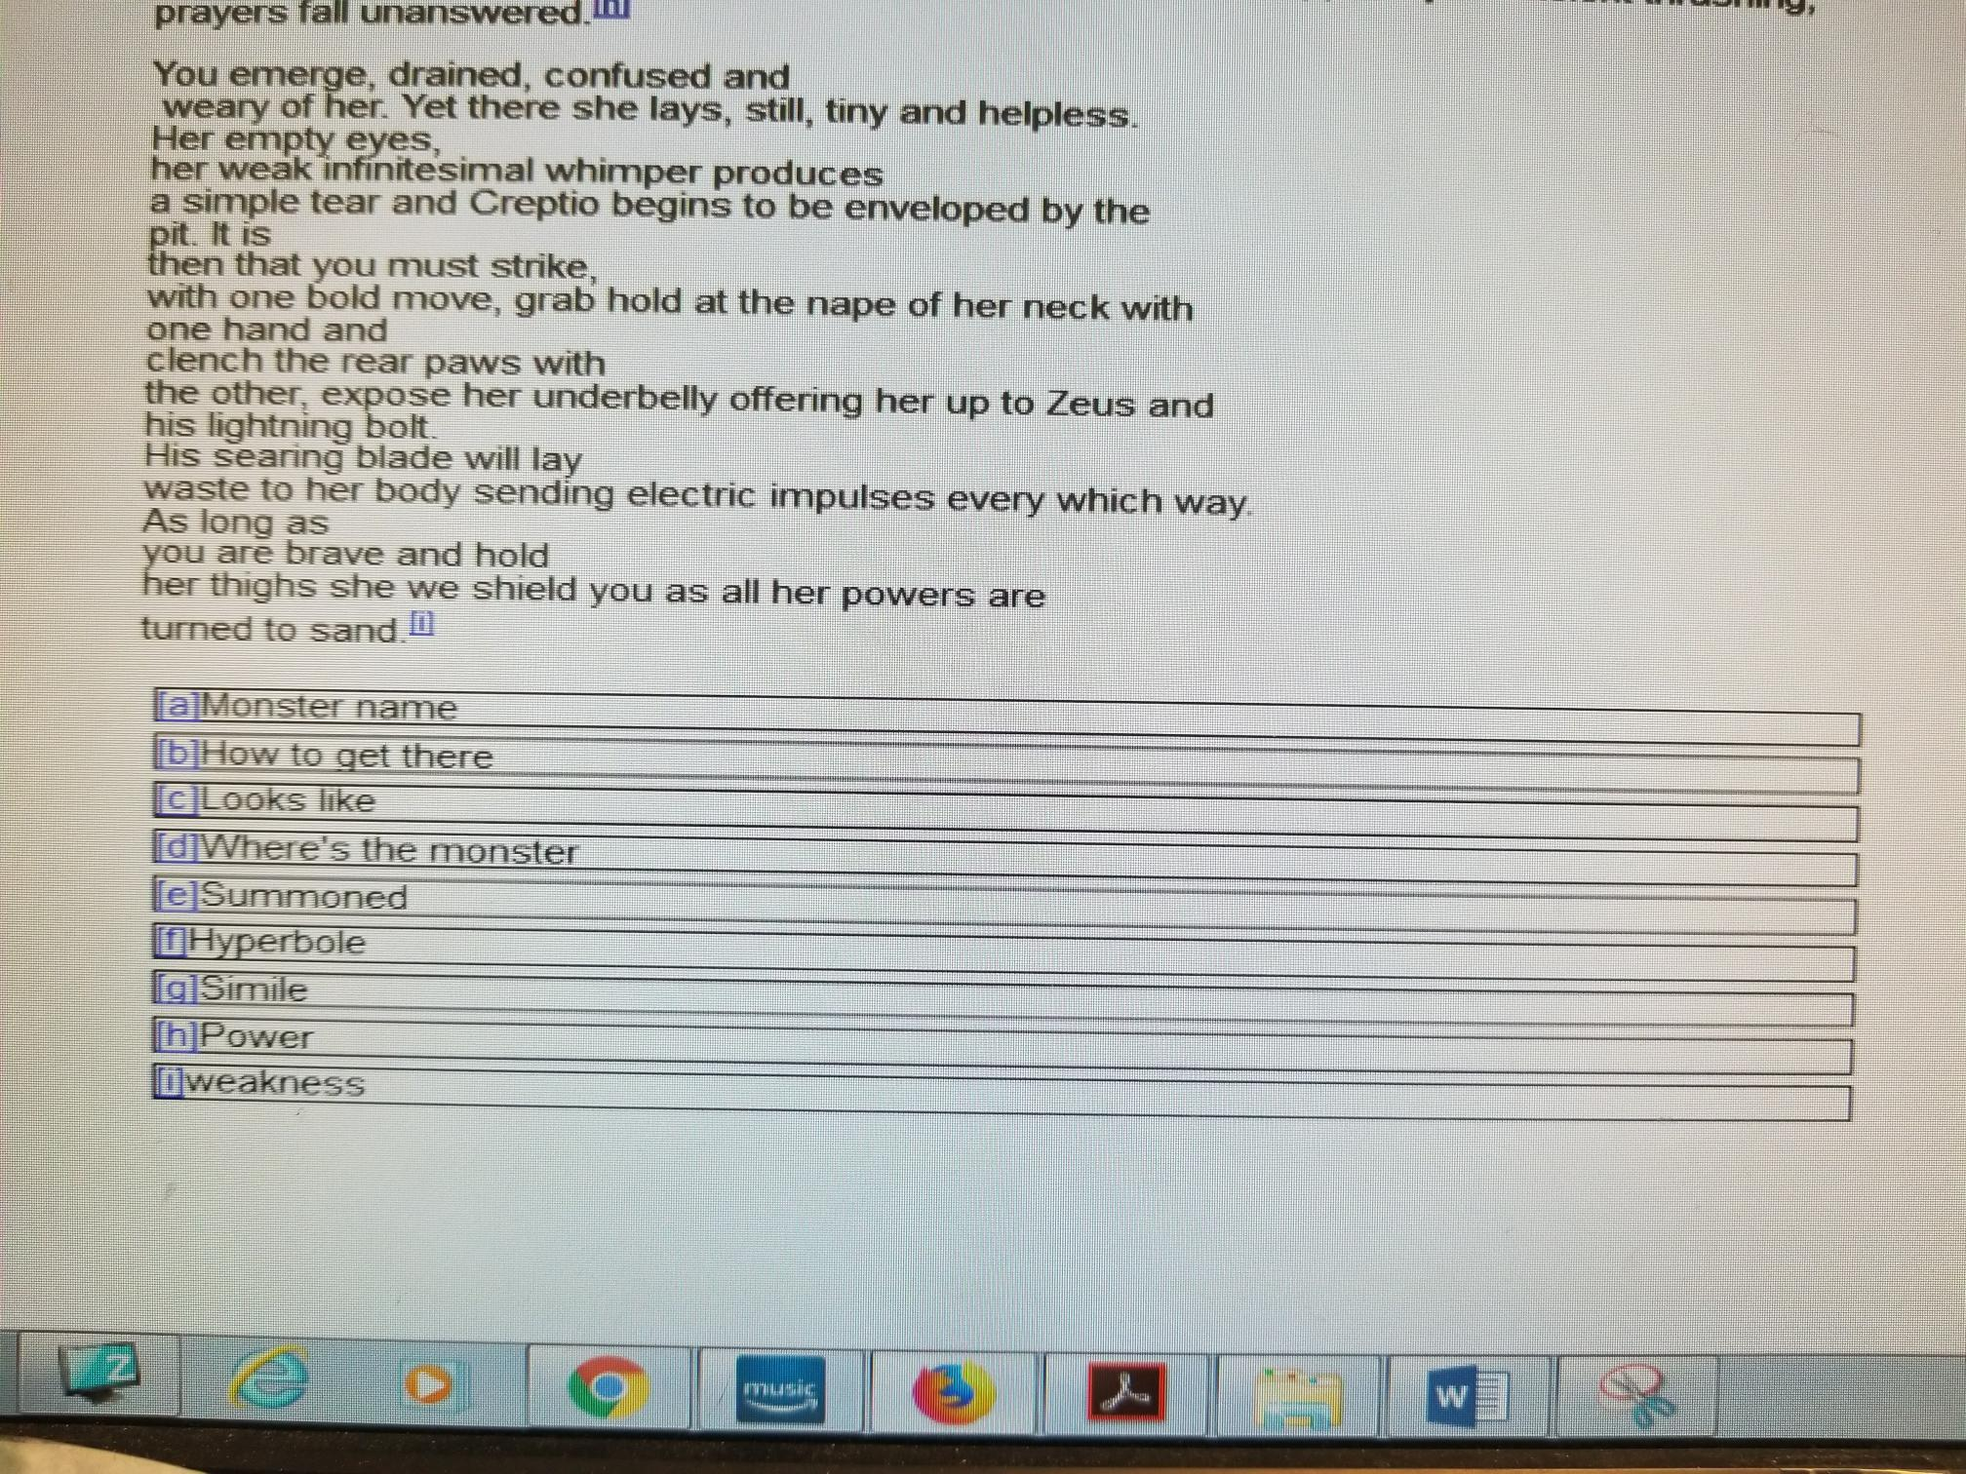
Print that page

