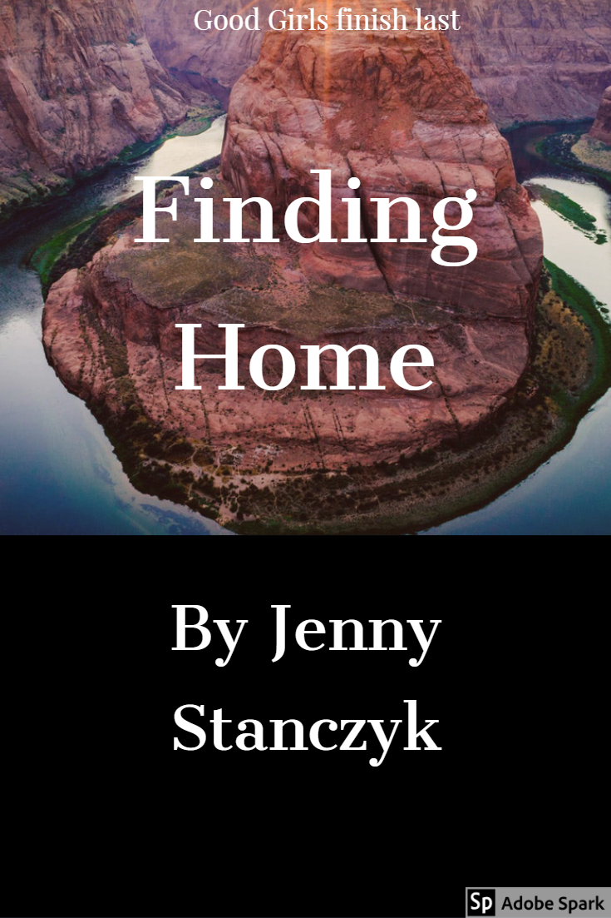

14 year old Charlotte Thibodaux did what her parents told her to do, like most kids at The Grosse Pointe Academy. Everyday when she entered the marble and granite vestibule she would pull and fidget with the school uniform hoping to cover any awkward parts and seamlessly blend in with the other students. It’s easy to disappear with brown hair, brown eyes and the same plaid uniform as everyone else. Everything had worked quite well until Sister Feterman reprimanded her for a comment that wasn’t hers and she hit back.

Sent to Outward Bound in the Colorado wilderness, to “build some character”, she finds herself facing her biggest enemy, herself. Charlotte will have to stop blending in and start fighting back if she wants to ever put that school uniform on again.

**GREAT PRAISE FOR FINDING HOME.**

*Finding Home is the next great American novel. –* ***Harper Lee***

*I have read this story 10 times now and keep wondering what will be next from Jenny Stanczyk.-* ***Oprah***

*I love the hunt and thought I had read everything on hunting, until now. Stanczyk does not disappoint.-* ***Sanger Rainsford***



Jenny Stanczyk is the author of 1 award winning poem and 5 failed screenplays. Ms.Stanczyk attended and was kicked out of some of the most prestigious boarding schools in the country, including Georgetown Prep and The University of Liggett. She lives on a 40 acre homestead in Northern Michigan with her wife and 2 dogs.