Go to Vocabulary.com
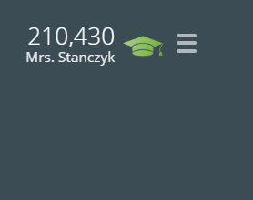
Level
Activity Progress
(District Writing Performance )
Trouble Words
Mastered

Scroll down to My Progress, fill in the table below.

Click on District Writing Performance, under Activity Progress,
% for Questions
Points earned

Go to achievements
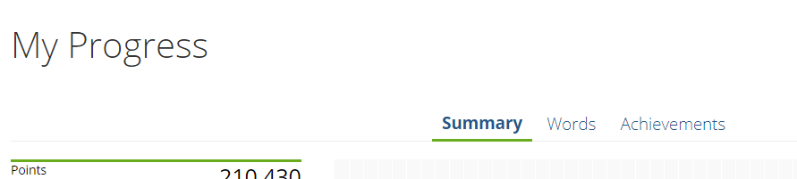
What level do you think you can reach by January 1?

