Go to: www.stanczyk.weebly.com

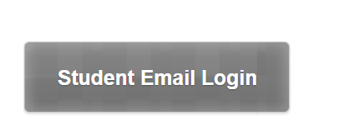
Scroll down the page to the square that says

Login using: student number@wcskids.net
Password is your school password
Set up your email. Your signature should be your name
Log out

Go back to www.stanczyk.weebly.com
Click on Vocabulary.com set up
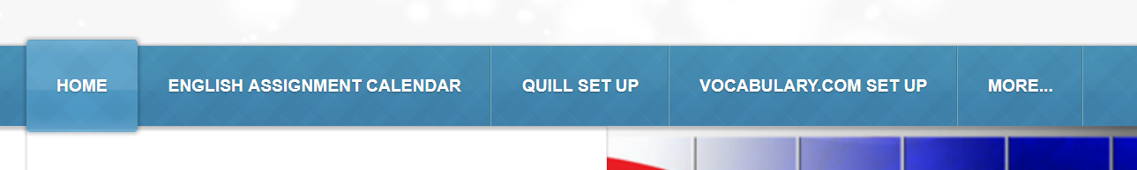

Follow the link for your hour
If you have signed up for another class just login, if you have not click on, Sign up now. Use your school email address (studentnumber@wcskids.net) and your student password. This will make it easy if you forget your password.
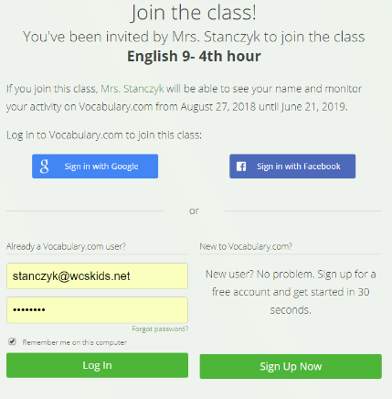

Begin work on your first assignment.
Tuesday
Go back to: www.stanczyk.weebly.com
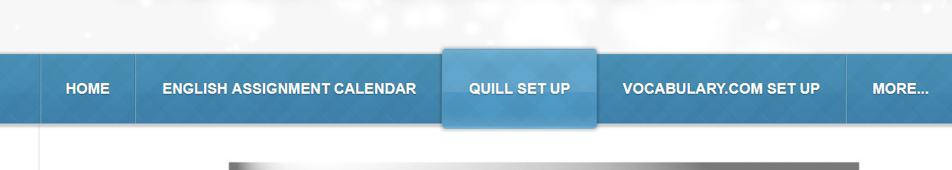
Click on Quill setup

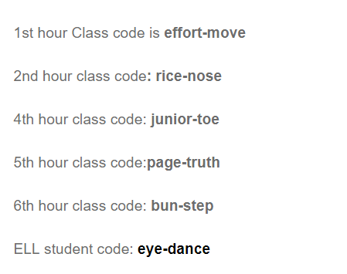
Write down the class code FOR YOUR HOUR.

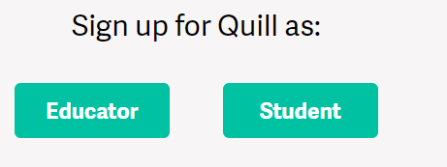
Click on the link for student signup
Choose student

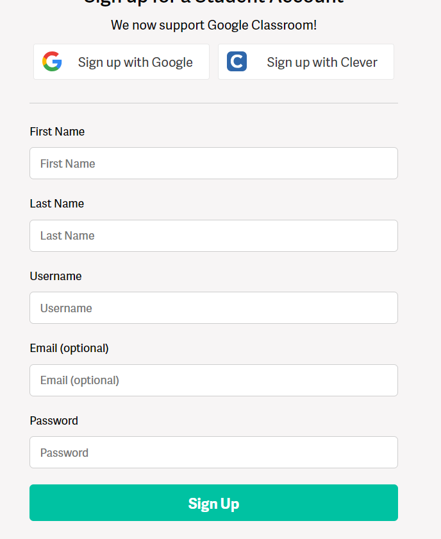
Username should be Your first and last name with no spaces,
if user name is taken add CHS to the end.

Use your school email address and password for the setup.

Take the Sentence Structure Diagnostic or ELL Diagnostic
if you do not complete in class you must complete at home.

