English 9 Website work
Diagnostic test
Go to www.stanczyk.weebly.com
Click on the Links page and select “must have links” for all of these tasks unless otherwise instructed.
Diagnostic test. Before completing any other tasks you MUST take the Quill grammar and writing diagnostic. You must try because the diagnostic may assign additional work you know how simply because you didn’t try on the diagnostic. Do not create more work for yourself.
- Follow the link for www.Quill.org/account/new
- Sign up
- Once you sign up, in the "Join My Class" field, enter the class code for your hour, on the board. Make sure it is for your hour!
- Take the Diagnostic test.

Tasks to complete
*For any account you create for this class use your first and last name as your user name, if you need to add numbers to the account, because it is already being used, trying using your graduation year.
For example: JennyStanczyk84
*Most of these accounts do not allow me to look up passwords, if you can use the same password you have for school so I can look it up if you forget it.

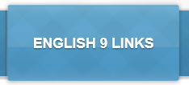
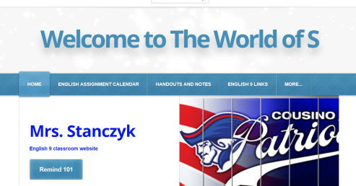
- Find the links page on my website www.stanczyk.weebly.com

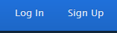
A. If you have not, go to Remind 101 and sign up using your cell phone.
Don’t forget to Return to my Links page
B. Follow the link Vocabulary.com on my links page.
    - go to sign up at the bottom right hand corner
    - Fill in the blank fields- DO NOT USE Facebook or Google links, use a real email address.
    - You will have one assignment pending that is due Friday. You may start now or work on it at home.
C. Follow the link to newsela.com or use code WPU9GF
i. Select “It’s my first time here” or “I have a Newsela account”.
ii. Sign up
iii. The assigned article and work is due by Monday September 18.
D. Follow the link for Goodreads.com and sign up for an account .
Don’t forget to Return to my Links page
    - Skip the Get book recommendations from your friends!
    - Set your reading goal to 4 books
    - Fill in the Select Genre section, you can fill in the next two at home.
    - If you followed my link you do not have to the next 4 steps.
    - Go back to the home page by clicking on
    - Click on the 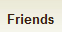 button on the top of the page
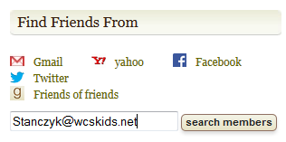
    - On the right side of the page type in my email address and search
    - Add me as a friend so you can view my classroom library
    - Select at least 5 books from my library and select them as “want to read”.

E. Go to Handouts and Notes on my website, click on Beginning of the year.
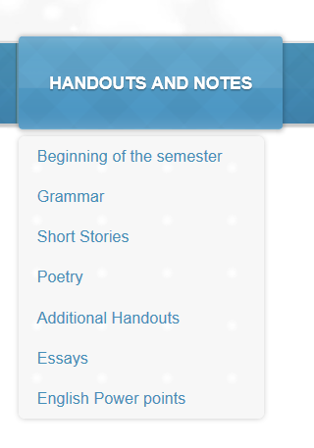
Download the Syllabus and print it, ONCE, or email it to your parents.
It must be signed by the due date or your parents may send me an email or text via remind that says they have read the syllabus.

